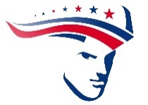
SATURDAY, OCTOBER 11TH 9AM – 1PM
PATRIOTS
CAR & BIKE SHOW

625 MARINA BLVD, BULLHEAD CITY
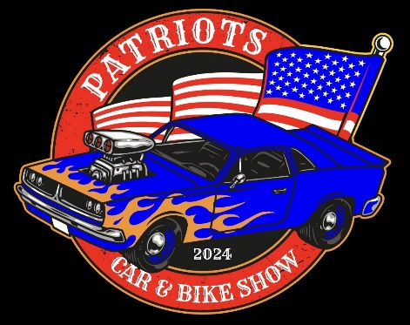
- OPEN TO PUBLIC
- FOOD
- MALC MARKET
- PRIZES
- JUDGED BY KINDERGARTENERS

$25.00 to register a car or bike: includes event shirt
The 14th annual Patriots Car & Bike Show will not be judged by professional judges like traditional car shows. It will be judged by the kindergarten students of Mohave Accelerated Schools. In the eyes of our children, let’s find out who really does have the coolest car & bike in the Tri-State Area! Note: our annual MALC MARKET will be taking place at the same time with food, games, prizes, and items for sale. You can register a car (all years, makes, models, welcome) or motorcycle the day of the event, or fax this entry form to (928) 704-4977 and/or email nperez@mohavelearning.org. For questions, call Nena Perez at (928) 704-9345 x130.

_____________________________________________________________________ Name (First/Last)

_______________________________________________________________________
Email

_____________ ______________________ ____________ _______________
Make Model Year Shirt Size

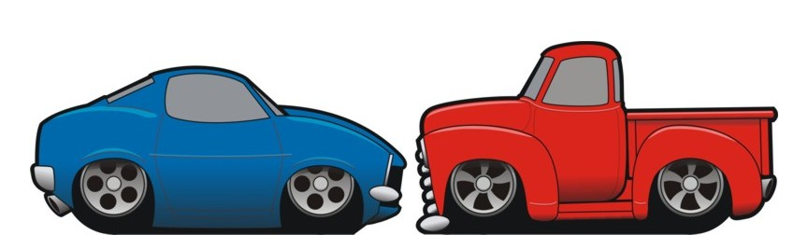
_____ I would like an extra event T-Shirt – Cost $15 _____________
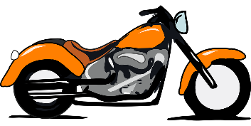
Shirt Size

